EMERGENCY FOOD
HAMPER PROGRAM
INFORMATION SYSTEM

SPECIFICATIONS

September 6, 2003

TABLE OF CONTENT
Introduction 4
Purpose 4
System Overview 4
System Walkthrough 7
Processes 8
Main Input 8
Searching and Selecting Existing Information 8
Adding, Updating or Deleting Detailed Information 9
Region of Waterloo Social Service Billing Submission 9
Region of Waterloo Social Planning Statistics Submission 11
System Maintenance 11
The Password System 11
Changing/Updating System Codes 12
Year - End Procedures 12
Backing-Up the System 13
Issues 13
Information Confidence 13
Information Confidentiality 14
Future Research Capability 14
Guidelines for system updates and modifications 14
Appendix 1: System Output 15
Reports 15
Region of Waterloo Social Service Preliminary Invoice 15
Region of Waterloo Social Service Preliminary Billing Listing 16
Region of Waterloo Social Service Final Invoice 17
Region of Waterloo Social Service Final Billing Listing 18
Region of Waterloo Social Services Orders Not Eligible 19
Region of Waterloo Social Service Matching Report 20
The Food Bank of Waterloo Region Hunger Count - Hamper Form 21
CAFB Hungercount Report 22
Individual Profile 23
Family Profile 27
Summary of Persons Served 29
Summary of Services Provided 31
Summary of Services Provided by Month 34
Delivery Report 36
Appendix 2: System Input 37
Forms 37
Opening Form 37
Password Entry 38
Main Input - Search 39
Main - Input - Input - Person 40
Main - Input - Input - Family 41
Main - Input - Input - Address 42
Main - Input - Input - Order 43
Billing Comparison 44
Agency Selection 45
Time Period Selection 46
Product Setup 47
Code Setup - Input 48
Code Setup - Output 49
Appendix 3: System Tables 50
Appendix 4: Calculated Variables 53
Appendix 5: Master Menu 55

Introduction

Purpose

The Emergency Food Hamper Program Information System is design to provide information on the Emergency Food Hamper Program for Region of Waterloo, Social Services Department and the five community agencies: House of Friendship Emergency Food Hamper Program, Salvation Army Kitchener, Cambridge Self Help Food Bank, Salvation Army Cambridge, Woolwich Community Services.

In particular the system will:

- Provide information to the Region to facilitate the Emergency Food Hamper Program billing matching process.

- Provide information to the Region for social planning purposes associated with the Emergency Food Hamper Program.

- Provide information to the community agencies for their administrative and planning purposes.

System Overview

Figure 1 presents a conceptual system overview of the Emergency Food Hamper Program Information System. The system is designed to allow the community agencies to enter the data at the time of services.

The system involves a family ordering products from the community agency.

The family consists of:
- One or more persons
- One person must be designated as the head.
- All other persons must be related to the head.

The product consists of the one or more products (hampers, diapers, formula) and/or services provided by the community agency under the Emergency Food Hamper Program.

Community Agencies will be able to add/update their products/services as outlined in the Changing/Updating System Codes section below.

Periodically, usually at the beginning of the month, the community agencies can produce the reports and data extract files as outlined in Appendix 1 Extract Tables.

The data extract tables will be sent by email to the Region of Waterloo Social Services Department.

The Region of Waterloo Social Services Department will use the invoice extract table to determine the eligibility for reimbursement. An Exception Report will be sent to the community agencies of ineligible orders.

The statistic extract table will be used to produce region wide social planning statistics. The same reports (Appendix 1: Reports) will be used for regional and community agency.
Figure 1: Conceptual System Overview
Person Person Person
Member Member Member

Family
1 head

Orders

Products

Hampers

Diapers

Formula

Voucher

Statistics
Extract
Invoice
Extract

Statistics
Extract
Invoice
Extract
OW Cheque Register
Extract

Name
Comparison

Region Wide Statistics
Reports
Final Invoice
&
Cheque Requisition
Orders Not Eligible
Report

System Walkthrough

The system walkthrough is an overview of the Emergency Food Hamper Program Information System as a user will encounter it.

Upon start-up or a different user, the user must login. Details of the login are outlined in the Password System Section of the specifications.

If the user has authorization to more than one function in the system, a customised menu will appear, otherwise the specific function will be loaded.

The system’s functions are divided in four categories: Input Form, Output Reports, Processes and System Maintenance. The menu structure is outlined in Appendix 5: Master Menu.

The main input form is divided into left-hand side (summary and selection information) and right-hand side (detailed information for data entry).

Functions of the main input form are:

- Searching and selecting existing information. Details of searching are presented in the Searching Section of the specifications.

- Adding, updating, or deleting detailed information. Details of adding, updating or deleting detailed information are presented in the Adding, Updating or Deleting Detailed Information Section of specifications.

The output reports are presented in the Output Section of the specifications. For reports involving time periods, the user will choose the month period or a custom period with a “From” and “To” date. See the Time Period Input Form in the Input Forms Section of the specifications.

In the current version of the Emergency Food Hamper Program Information System, the comparison of data for two or more time periods or a time period spanning fiscal (January - December) years must be done manually:
- A separate report is prepared for each time period
- A composite report is created using a word processor or spreadsheet

System maintenance functions of the Emergency Food Hamper Program Information System are: managing passwords, changing/updating system codes, year-end procedures and backing-up the system. Details of these functions are presented in the respective sections of the specifications.

Processes

Main Input

Searching and Selecting Existing Information

The Searching and Selecting Existing Information form, outlined in the Input Forms section of the specifications, consist of two parts

The left side contains the search criteria, (Person’s Name, Date of Birth, Address, Person ID, Family ID, Order ID), the list of the family name (head) of all responses meeting the search criteria, and the ‘NEW’, ‘SEARCH’ and ‘ACCEPT’ buttons.

The right side displays the Persons in Family and Orders for Family of the family name selected from the list on the left side.

If multiple criteria are enter they will be connected with ‘and’. The * may be used in the name and address criteria as the wild card,

When the ‘SEARCH’ button is pressed, the list of the family name (head) of all responses meeting the search criteria is filled. If no criteria are used, the list is filled with all the family heads.

A family may be selected from the list box or the ‘NEW’ button will create a new family.

When the ‘ACCEPT’ button is pressed, the selected or new family is transferred to the working tables and the Adding, Updating or Deleted Form as outlined in the Input Forms section of the specifications, is displayed. Details of adding, updated or deleted information are outlined in the Adding, Updating or Deleting Detailed Information section of specifications.

Adding, Updating or Deleting Detailed Information

The Adding, Updating or Deleting Form, outlined in the Input Forms section of the specifications, consists of two parts.

The left side contain the Persons in Family list, the Orders for Family list, and the ‘CANCEL’ and ‘SAVE’ buttons.

The right side allow the adding updating, or deleting of detailed information for family members and/or orders selected from the lists on the left.

Region of Waterloo Social Service Billing Submission

An order will be considered for billing when:

The head of the family is over 18

No one in the family is on Ontario Works

Products in the order are eligible for reimbursement

The order is less than maximum orders allowed or the order has an authorization number

Billings to Region of Waterloo Social Services will normally be made at the beginning of month for the previous month. A custom billing may be made by specifying the beginning and ending dates.

When the “Region of Waterloo Social Service Billings Submission” is selected from the menu, see the Master Menu Section of the specifications, the time period, the month period or a custom period with a “From” and “To” date, is selected. See the Time Period Input Form in Appendix 3: System Input - Forms. The Region of Waterloo Social Service Billing Tables extract, containing family name (name of Head), DOB, current address, see Appendix 1: - Extract Tables, is created.

The Region of Waterloo Social Service Statistic Update Tables are created from the last update date to the billing ‘TO’ date.

Both extract tables are emailed to the Region of Waterloo Social Services Department.

A Preliminary Invoice and a Preliminary Billing Listing may be printed. See Appendix 1: - System Output - Reports.

The Region of Waterloo Social Services Department compares the Region of Waterloo Social Service Billing Table with the Region of Waterloo Social Services Department OW Cheque Register Table.

Using the Billing Comparison Form, see Appendix 2: - System Input - Forms, a name is selected from the Order Name List all corresponding names from the OW Cheque Register. If the ‘Sounds Like’ button is pressed the search is done using the soundex function giving a broader range of names.

The order selected may be accepted or rejected using ‘ACCEPT’ or ‘REJECT’ buttons, if rejected, a reason must be given. The name is removed from the Order Name List. The ‘REVIEW’ button allows a review of processed orders. An order may be return to the Order Name List for further processing.

When all the Order Names are processed, a Final Invoice, a Final Billing Listing, Orders Not Eligible Report, and a Cheque Requisition Report may be printed. See Appendix 1: - System Output.

The Final Invoice, a Final Billing Listing, and Orders Not Eligible Report can be forwarded to the Community Agency.

Region of Waterloo Social Planning Statistics Submission

The Region of Waterloo Social Service Department’s system is similar to Community Agencies system with the following exceptions:

- Input will be from The Region of Waterloo Social Service Statistic Update Tables rather than the Master Input form

- The Regional codes will be used.

- Output may be by individual community agency, grouped community agencies or region wide as selected through the Agency Selection form. See Appendix 1: - System Input - Forms.

- Persons names, telephone numbers and address(es), except the postal codes are omitted to insure confidentiality.

The Region of Waterloo Social Service Statistic Update Tables is created through the Region of Waterloo Social Service Billings Submission process or by selecting “Region of Waterloo Social Service Statistics Submission” from the menu. See Appendix 5: - Master Menu.

The Region of Waterloo Social Service Statistics is updated from the Region of Waterloo Social Service Statistic Update Tables by selecting “Region of Waterloo Social Service Statistics Update” from the menu. See Appendix 5: - Master Menu. The updating is automatic.

The Region of Waterloo Social Services will be able to create all reports in the system with Region wide or combination of agency data. See Appendix 2: System Input-Forms-Agency-Selection.

System Maintenance

The Password System

When entering the system or changing users, the user must login. The login serves four purposes:

- Identifies an authorized user
- Identifies who has created or updated the information
- Gives access to only required functions in the system
- For limited users allows the changing of the system date

A user must be set-up along with the system function the user requires. If the user requires one than one function a custom menu is displayed, otherwise the function is displayed directly.

Changing/Updating System Codes

Changing/Updating System Codes allows the user to manage codes used in the system. There are two components: input codes and output codes. Each field or calculated variable must have its own codes. Codes from existing fields/variables may be copied to a new field/variable.

The input codes, as stored in the fields of the tables, must be in atomic form, the finest detail. The order in which the input codes are displayed can be specified. The input codes must be consistent with the regional codes. It is recommended that alpha codes (using letters) be used.

The output codes, displayed on reports, may be the ‘same as input’ or have several different formats. Output codes may be collapsed by assigning the same descriptions to more the one input code.

Codes may be deleted if and only if they are NOT used in the database.

A code book of system codes can be printed.

Year - End Procedures

The Emergency Food Hamper Program Information System functions on a January 1st to December 31st fiscal year. While the year-end procedures are manually triggered by selecting “Year-end” from the menu, see Appendix 5: - Master Menu. The year-end procedures should be done in early January of the New Year.

The structure of the Archived Emergency Food Hamper Program Information System is the same as the current one except the “Archived Year” field is added to each table.

When “Year-end” is selected, the following occurs:

- Orders occurring before December 31st of the previous year are written to the Archived EFHP system and deleted from the current system.

- The “BillNo” and “NonBillNo” counters of any existing orders are set accordingly (starting at 1).

- All remaining records which have NOT been modified in the past two years are written to the Archived EFHP system and deleted from the current system.

Backing-Up the System

When the “System Backup” is selected from the menu, see the Appendix 5: Master Menu Section of the specifications,

Issues

Information Confidence

Information confidence is the degree to which the System Output (Appendix 1) is seen to be an accurate reflection of the reality of delivering, managing, reimbursing and planning in the Emergency Food Hamper Program.

Information confidence involves both the integration of the Emergency Food Hamper Program Information System into the community organizations and the Regional Social Service Department and the integrity of the EFHP Information System itself.

The first, the integration into the community organizations and the Regional Social Service Department, will be part of the system implementation phase and will involved staff training and the initial system monitoring.

The second, the integrity of the system, will involve the review and approval of the system’s specifications by the stakeholders, the use of standard database design and development criteria, through system and implementation testing and guidelines for system updating and modifications.

Caution must be taken in using the term “statistics”. A statistic is a technical, usually mathematical, procedure used to describe a group or collection of items. It may or may not have meaning or value to be used as information (Consider the meaning of the statistic 2.5 children per family - exactly what is a .5 child)

Information Confidentiality

Information confidentiality is the protection and privacy of all parties, clients, agencies and the Region. It poses moral, ethical and legal issues in balancing protection/privacy with information confidence.

The major issue related to the Emergency Food Hamper Program Information System is the providing of information to the region through a third party, the community agencies.

This issue can be resolved by the signing of a waiver by the recipient acknowledging the awareness that:

- Their name, date of birth and current address may be used to determine the eligibility for reimbursing the agency.
- Other information except name, date of birth and current address (except postal code) may be used in aggregated form for planning purposes.

Future Research Capability

The Emergency Food Hamper Program Information System does have a capacity for future research both at the individual community agency level and the regional level. However, most research projects start with a theoretical base and then develop a data gathering instrument based on that base. If the data in the Emergency Food Hamper Program Information System fits the theoretical base of the research it is a valuable resource. However, one must be careful not to build a theoretical base just because data is available or collect data ‘just in case’ it has a use in the future.

Guidelines for system updates and modifications

The purpose of these guidelines is to maintain the integrality of the Emergency Food Hamper Program Information System. Considerable flexibility has been built into the system to provide user customization. However, there will be times when more extensive modifications are required.

Appendix 1: System Output

Reports

Region of Waterloo Social Service Preliminary Invoice

AGENCY  SYMBOL | AGENCY NAME  STREET, CITY, PROV, , POSTALCODE  Telephone: (xxx) xxx-xxxx Fax: (xxx) xxx-xxxx  Email: xxxxxx@xxxxxxxxxxxx.xxx  Contact: xxxxxxxxxxxxxxxxxxxxxxx

TO: Social Services Department, Preliminary Invoice
Regional Municipality of Waterloo,
99 Regina Street South,
Waterloo, Ontario N2J 4G6

FOR THE PERIOD: dd mmm yyyy TO dd mmm yyyy

Quantity Item Unit Price Total

nnnn xxxxxxxxxxxxxxxxxxxxxxxxxxxxxx $ nn.nn $ n.nnn.nn
nnnn xxxxxxxxxxxxxxxxxxxxxxxxxxxxxx $ nn.nn $ n.nnn.nn
nnnn xxxxxxxxxxxxxxxxxxxxxxxxxxxxxx $ nn.nn $ n.nnn.nn
nnnn xxxxxxxxxxxxxxxxxxxxxxxxxxxxxx $ nn.nn $ n.nnn.nn
nnnn xxxxxxxxxxxxxxxxxxxxxxxxxxxxxx $ nn.nn $ n.nnn.nn

Total $ nn,nnn.nn

Region of Waterloo Social Service Preliminary Billing Listing

AGENCY  SYMBOL | AGENCY NAME  STREET, CITY, PROV, POSTALCODE  Telephone: (xxx) xxx-xxxx Fax: (xxx) xxx-xxxx Email: xxxxxx@xxxxxxxxxxxx.xxx  Contact: xxxxxxxxxxxxxxxxxxxxxxx

Preliminary Billing Listing

FOR THE PERIOD dd mmm yyyy TO dd mmm yyyy

Date Order ID Family ID/ Authorization # Family Head/ Quantity Item(s)

dd mmm yyy nnnnnn nnnnnn nnnnnnnnnn xxxxxxxxxxxxxxxxxxxxxxxx
nn xxxxxxxxxxxxxxxxxxxxxxxxxxxxxx
nn xxxxxxxxxxxxxxxxxxxxxxxxxxxxxx
nn xxxxxxxxxxxxxxxxxxxxxxxxxxxxxx

dd mmm yyy nnnnnn nnnnnn nnnnnnnnnn xxxxxxxxxxxxxxxxxxxxxxxx
nn xxxxxxxxxxxxxxxxxxxxxxxxxxxxxx
nn xxxxxxxxxxxxxxxxxxxxxxxxxxxxxx
nn xxxxxxxxxxxxxxxxxxxxxxxxxxxxxx

dd mmm yyy nnnnnn nnnnnn nnnnnnnnnn xxxxxxxxxxxxxxxxxxxxxxxx
nn xxxxxxxxxxxxxxxxxxxxxxxxxxxxxx
nn xxxxxxxxxxxxxxxxxxxxxxxxxxxx
nn xxxxxxxxxxxxxxxxxxxxxxxxxxxxxx

dd mmm yyy nnnnnn nnnnnn nnnnnnnnnn xxxxxxxxxxxxxxxxxxxxxxxx
nn xxxxxxxxxxxxxxxxxxxxxxxxxxxxxx
nn xxxxxxxxxxxxxxxxxxxxxxxxxxxxxx
nn xxxxxxxxxxxxxxxxxxxxxxxxxxxxxx

dd mmm yyy nnnnnn nnnnnn nnnnnnnnnn xxxxxxxxxxxxxxxxxxxxxxxx
nn xxxxxxxxxxxxxxxxxxxxxxxxxxxxxx
nn xxxxxxxxxxxxxxxxxxxxxxxxxxxxxx
nn xxxxxxxxxxxxxxxxxxxxxxxxxxxxxx

Region of Waterloo Social Service Final Invoice

REGION  SYMBOL | Social Services Department Regional Municipality of Waterloo 99 Regina Street S WATERLOO, Ontario N2J 4V6  Telephone: (519) 883-2020 Fax: (519) 884-6385 Email: theiszbo@region.waterloo.on.ca  Contact: Bob Theisz

TO: Agency Contact Final Invoice
Agency Name
Street, City, Prov, , Postalcode

FOR THE PERIOD: dd mmm yyyy TO dd mmm yyyy

Quantity Item Unit Price Total

nnnn xxxxxxxxxxxxxxxxxxxxxxxxxxxxxx $ nn.nn $ n.nnn.nn
nnnn xxxxxxxxxxxxxxxxxxxxxxxxxxxxxx $ nn.nn $ n.nnn.nn
nnnn xxxxxxxxxxxxxxxxxxxxxxxxxxxxxx $ nn.nn $ n.nnn.nn
nnnn xxxxxxxxxxxxxxxxxxxxxxxxxxxxxx $ nn.nn $ n.nnn.nn
nnnn xxxxxxxxxxxxxxxxxxxxxxxxxxxxxx $ nn.nn $ n.nnn.nn

Total $ nn,nnn.nn

Region of Waterloo Social Service Final Billing Listing

REGION  SYMBOL | Social Services Department Regional Municipality of Waterloo  99 Regina Street S WATERLOO, Ontario N2J 4V6  Telephone: (519) 883-2020 Fax: (519) 884-6385  Email: theiszbo@region.waterloo.on.ca  Contact: Bob Theisz
Final Billing Listing

FOR THE PERIOD dd mmm yyyy TO dd mmm yyyy

TO: Agency Contact
Agency Name
Street, City, Prov, Postalcode

Date Order ID Family ID/ Authorization # Family Head / Quantity Item(s)

dd mmm yyy nnnnnn nnnnnn nnnnnnnnnn xxxxxxxxxxxxxxxxxxxxxxxxxxxxxx
nn xxxxxxxxxxxxxxxxxxxxxxxxxxxxxx
nn xxxxxxxxxxxxxxxxxxxxxxxxxxxxxx
nn xxxxxxxxxxxxxxxxxxxxxxxxxxxxxx

dd mmm yyy nnnnnn nnnnnn nnnnnnnnnn xxxxxxxxxxxxxxxxxxxxxxxxxxxxxx
nn xxxxxxxxxxxxxxxxxxxxxxxxxxxxxx
nn xxxxxxxxxxxxxxxxxxxxxxxxxxxxxx
nn xxxxxxxxxxxxxxxxxxxxxxxxxxxxxx

dd mmm yyy nnnnnn nnnnnn nnnnnnnnnn xxxxxxxxxxxxxxxxxxxxxxxxxxxxxx
nn xxxxxxxxxxxxxxxxxxxxxxxxxxxxxx
nn xxxxxxxxxxxxxxxxxxxxxxxxxxxxxx
nn xxxxxxxxxxxxxxxxxxxxxxxxxxxxxx

dd mmm yyy nnnnnn nnnnnn nnnnnnnnnn xxxxxxxxxxxxxxxxxxxxxxxxxxxxxx
nn xxxxxxxxxxxxxxxxxxxxxxxxxxxxxx
nn xxxxxxxxxxxxxxxxxxxxxxxxxxxxxx
nn xxxxxxxxxxxxxxxxxxxxxxxxxxxxxx

dd mmm yyy nnnnnn nnnnnn nnnnnnnnnn xxxxxxxxxxxxxxxxxxxxxxxxxxxxx
nn xxxxxxxxxxxxxxxxxxxxxxxxxxxxxx
nn xxxxxxxxxxxxxxxxxxxxxxxxxxxxxx
nn xxxxxxxxxxxxxxxxxxxxxxxxxxxxxx

Region of Waterloo Social Services Orders Not Eligible

REGION  SYMBOL | Social Services Department Regional Municipality of Waterloo  99 Regina Street S WATERLOO, Ontario N2J 4V6  Telephone: (519) 883-2020 Fax: (519) 884-6385  Email: theiszbo@region.waterloo.on.ca  Contact: Bob Theisz

Orders Not Eligible

FOR THE PERIOD dd mmm yyyy TO dd mmm yyyy

TO: Agency Contact
Agency Name
Street, City, Prov,, Postalcode

Date Order ID Family ID Family Head Reason

dd mmm yyy nnnnnn nnnnnn xxxxxxxxxxxxxxxxxxxxxxx xxxxxxxxxxxxxxxxxxxxx
dd mmm yyy nnnnnn nnnnnn xxxxxxxxxxxxxxxxxxxxxxx xxxxxxxxxxxxxxxxxxxxx
dd mmm yyy nnnnnn nnnnnn xxxxxxxxxxxxxxxxxxxxxxx xxxxxxxxxxxxxxxxxxxxx
dd mmm yyy nnnnnn nnnnnn xxxxxxxxxxxxxxxxxxxxxxx xxxxxxxxxxxxxxxxxxxxx
dd mmm yyy nnnnnn nnnnnn xxxxxxxxxxxxxxxxxxxxxxx xxxxxxxxxxxxxxxxxxxxx
dd mmm yyy nnnnnn nnnnnn xxxxxxxxxxxxxxxxxxxxxxx xxxxxxxxxxxxxxxxxxxxx
dd mmm yyy nnnnnn nnnnnn xxxxxxxxxxxxxxxxxxxxxxx xxxxxxxxxxxxxxxxxxxxx

Region of Waterloo Social Service Matching Report
REGION  SYMBOL | Social Services Department Regional Municipality of Waterloo  99 Regina Street S WATERLOO, Ontario N2J 4V6  Telephone: (519) 883-2020 Fax: (519) 884-6385  Email: theiszbo@region.waterloo.on.ca  Contact: Bob Theisz
MATCHING REPORT
FOR THE PERIOD dd mmm yyyy TO dd mmm yyyy
Item Number Dollars
xxxxxxxxxxxItemxxxxxxxxxxxxxxxxxxxxxxxxxxxxx
Total ACCEPTED Orders nnnn $ nn,nnn.nn
Total OW Orders nnnn $ nn,nnn.nn
Total NON OW Orders nnnn $ nn,nnn.nn
Total UNCLEAR Orders nnnn $ nn,nnn.nn
Total Orders nnnn $ nn,nnn.nn

xxxxxxxxxxxItemxxxxxxxxxxxxxxxxxxxxxxxxxxxxx
Total ACCEPTED Orders nnnn $ nn,nnn.nn
Total OW Orders nnnn $ nn,nnn.nn
Total NON OW Orders nnnn $ nn,nnn.nn
Total UNCLEAR Orders nnnn $ nn,nnn.nn
Total Orders nnnn $ nn,nnn.nn

xxxxxxxxxxxItemxxxxxxxxxxxxxxxxxxxxxxxxxxxxx
Total ACCEPTED Orders nnnn $ nn,nnn.nn
Total OW Orders nnnn $ nn,nnn.nn
Total NON OW Orders nnnn $ nn,nnn.nn
Total UNCLEAR Orders nnnn $ nn,nnn.nn
Total Orders nnnn $ nn,nnn.nn

xxxxxxxxxxxItemxxxxxxxxxxxxxxxxxxxxxxxxxxxxx
Total ACCEPTED Orders nnnn $ nn,nnn.nn
Total OW Orders nnnn $ nn,nnn.nn
Total NON OW Orders nnnn $ nn,nnn.nn
Total UNCLEAR Orders nnnn $ nn,nnn.nn
Total Orders nnnn $ nn,nnn.nn

SUMMARY
Total ACCEPTED Orders nnnn $ nn,nnn.nn
Total OW Orders nnnn $ nn,nnn.nn
Total NON OW Orders nnnn $ nn,nnn.nn
Total UNCLEAR Orders nnnn $ nn,nnn.nn
Total Orders nnnn $ nn,nnn.nn

The Food Bank of Waterloo Region Hunger Count - Hamper Form
Hamper Count - Hamper Form
Agency Name
Agency Contact

FOR THE PERIOD dd mmm yyyy TO dd mmm yyyy
1. Distribution and Frequency
# of different households receiving 1 hamper nnnn
2 hampers nnnn
3 hampers nnnn
More than 3 hampers nnnn
TOTAL # of hampers served this month nnnnn
2. Household Source of Income
(Indicate the main source of income of each household listed in #1}
Full Time Employment nnnn
Part Time Employment nnnn
Employment insurance nnnn
Welfare/Ontario Works nnnn
Canada Pension Plan nnnn
Disability nnnn
Other Income nnnn
No income nnnn
Source of Income Unknown nnnn
Total nnnnn
3. Household Composition
(equal to # of households listed in # 1)
Single Parent Families nnnn
Two Parent Families nnnn
Childless Couple nnnn
Single People nnnn
Total nnnnn
4. Age
(List all client and household dependents)
Children (under age 18) nnnn
Adults (18 and over) nnnn
Total nnnnn

Please send completed forms each month to Wendi Campbell
Fax: (519) 743-8965- Email wendic@foodbankwloo.org
Mail: 5O Alpine Court, Kitchener, ON N2E 2M7

CAFB Hungercount Report
CAFB Hungercount

Agency Name
Agency Contact

FOR THE PERIOD dd mmm yyyy TO dd mmm yyyy

The following is information required to complete the Canadian Association of Food Bank’s Hungercount Survey. The numbers represents the questions on the 2003 survey.

6(A) How many individual persons received groceries from your food bank in the month of
March?
Adults (Regardless of Marital Status) nnnn
Children (under age 18) nnnn
Total nnnnn
(B) How many Households receive groceries in March nnnnn
(C) How many persons and households would you estimate received groceries from your
food bank over the last one-year period. (January-December)*?
Total Persons nnnnnn Total Households nnnnnn
* If a March-March count is wanted run to reports March-December and January-March
10(A) How much food did your agency distribute in March? nnnnnnnn Kg
12 Household Source of Income Assistances
Social Assistance nnnnnnn nn.nn%
Job Income nnnnnnn nn.nn%
Federal Employment insurance nnnnnnn nn.nn%
Disability nnnnnnnn nn.nn%
Pension Income nnnnnnnn nn.nn%
Student Loans nnnnnnnn nn.nn%
Other Income nnnnnnnn nn.nn%
No income nnnnnnnn nn.nn%

Total nnnnnnnn 100.00%
15 (A) Household Composition
Single Parent Families nnnnnnnn nn.nn%
Couples with no Children nnnnnnnn nn.nn%
Single People nnnnnnnn nn.nn%
Dual Parent Families nnnnnnnn nn.nn%
Total nnnnnnnn 100.00%

- Senior citizens (65+ years) nnnnnnnnn nn.nn%
College or University Students nnnnnnnnn nn.nn%

Individual Profile
AGENCY  SYMBOL | AGENCY NAME  STREET, CITY, PROV, POSTALCODE  Telephone: (xxx) xxx-xxxx Fax: (xxx) xxx-xxxx  Email: xxxxxx@xxxxxxxxxxxx.xxx  Contact: xxxxxxxxxxxxxxxxxxxxxxx

Individual Profile for -name-

Person ID nnnnn ID Required xxxxxxxx
Pervious ID nnnnn
Date Of Birth dd mmm yyyy
Age nn.nn Source of Income
Gender xxxxxx xxxxxxxxxxx
Diet xxxxxxxx xxxxxxxxxxx
Pregnant □ xxxxxxxxxxx
Volunteer □
Volunteer Comments xxxxxxxxxxxxxxxxxxxxxxxxxxxxxxx

Family
Family ID nnnnnn current/pervious From: dd mmm yyyy To: (dd mmm yyyy)

Address:
Current From: dd mmm yyyy To:
Apartment Streetnumber Street Buzzer Number xxxx
City, Prov, Postalcode

Telephone: (nnn) nnn-nnnn

Previous From: dd mmm yyyy To: dd mmm yyyy
Apartment Streetnumber Street Buzzer Number xxxx
City, Prov, Postalcode

Telephone: (nnn) nnn-nnnn

Previous From: dd mmm yyyy To: dd mmm yyyyy
Apartment Streetnumber Street Buzzer Number xxxx
City, Prov, Postalcode

Telephone: (nnn) nnn-nnnn

Members
Name Date Of Birth Age Gender Relationship

xxxxxxxxxxxxxxxxxxx dd mmm yyyy nn.nn xxxxxxxxx xxxxxxxxxxxxx
xxxxxxxxxxxxxxxxxxx dd mmm yyyy nn.nn xxxxxxxxx xxxxxxxxxxxxx

xxxxxxxxxxxxxxxxxxx dd mmm yyyy nn.nn xxxxxxxxx xxxxxxxxxxxxx
xxxxxxxxxxxxxxxxxxx dd mmm yyyy nn.nn xxxxxxxxx xxxxxxxxxxxxx
xxxxxxxxxxxxxxxxxxx dd mmm yyyy nn.nn xxxxxxxxx xxxxxxxxxxxxx

Orders

Order ID nnnnn Date dd mmm yyyy Delivery □ Number: nnn Billable nnn Non-billable

nn xxxxxxxxxxxxxxxItemxxxxxxxxxxxxxxxxxxxxxxxxxxxxxx
nn xxxxxxxxxxxxxxxItemxxxxxxxxxxxxxxxxxxxxxxxxxxxxxx
nn xxxxxxxxxxxxxxxItemxxxxxxxxxxxxxxxxxxxxxxxxxxxxxx

Order ID nnnnn Date dd mmm yyyy Delivery □ Number: nnn Billable nnn Non-billable

nn xxxxxxxxxxxxxxxItemxxxxxxxxxxxxxxxxxxxxxxxxxxxxxx
nn xxxxxxxxxxxxxxxItemxxxxxxxxxxxxxxxxxxxxxxxxxxxxxx
nn xxxxxxxxxxxxxxxItemxxxxxxxxxxxxxxxxxxxxxxxxxxxxxx

Order ID nnnnn Date dd mmm yyyy Delivery □ Number: nnn Billable nnn Non-billable

nn xxxxxxxxxxxxxxxItemxxxxxxxxxxxxxxxxxxxxxxxxxxxxxx
nn xxxxxxxxxxxxxxxItemxxxxxxxxxxxxxxxxxxxxxxxxxxxxxx
nn xxxxxxxxxxxxxxxItemxxxxxxxxxxxxxxxxxxxxxxxxxxxxxx

Family ID nnnnnn current/pervious From: dd mmm yyyy To: (dd mmm yyyy)
Address:
Current From: dd mmm yyyy To:
Apartment streetnumber Street
City, prov, postalcode

Telephone: (nnn) nnn-nnnn

Previous From: dd mmm yyyy To: dd mmm yyyy
Apartment streetnumber Street
City, prov, postalcode

Telephone: (nnn) nnn-nnnn

Previous From: dd mmm yyyy To: dd mmm yyyyy
Apartment streetnumber Street
City, prov, postalcode

Telephone: (nnn) nnn-nnnn
Members
Name Date OF Birth Age Gender Relationship

xxxxxxxxxxxxxxxxxxx dd mmm yyyy nn.nn xxxxxxxxx xxxxxxxxxxxxx
xxxxxxxxxxxxxxxxxxx dd mmm yyyy nn.nn xxxxxxxxx xxxxxxxxxxxxx
xxxxxxxxxxxxxxxxxxx dd mmm yyyy nn.nn xxxxxxxxx xxxxxxxxxxxxx
xxxxxxxxxxxxxxxxxxx dd mmm yyyy nn.nn xxxxxxxxx xxxxxxxxxxxxx
xxxxxxxxxxxxxxxxxxx dd mmm yyyy nn.nn xxxxxxxxx xxxxxxxxxxxxx

Orders

Order ID nnnnn Date dd mmm yyyy Delivery □ Number: nnn Billable nnn Non-billable

nn xxxxxxxxxxxxxxxItemxxxxxxxxxxxxxxxxxxxxxxxxxxxxxx
nn xxxxxxxxxxxxxxxItemxxxxxxxxxxxxxxxxxxxxxxxxxxxxxx
nn xxxxxxxxxxxxxxxItemxxxxxxxxxxxxxxxxxxxxxxxxxxxxxx

Order ID nnnnn Date dd mmm yyyy Delivery □ Number: nnn Billable nnn Non-billable

nn xxxxxxxxxxxxxxxItemxxxxxxxxxxxxxxxxxxxxxxxxxxxxxx
nn xxxxxxxxxxxxxxxItemxxxxxxxxxxxxxxxxxxxxxxxxxxxxxx
nn xxxxxxxxxxxxxxxItemxxxxxxxxxxxxxxxxxxxxxxxxxxxxxx

Order ID nnnnn Date dd mmm yyyy Delivery □ Number: nnn Billable nnn Non-billable

nn xxxxxxxxxxxxxxxItemxxxxxxxxxxxxxxxxxxxxxxxxxxxxxx
nn xxxxxxxxxxxxxxxItemxxxxxxxxxxxxxxxxxxxxxxxxxxxxxx
nn xxxxxxxxxxxxxxxItemxxxxxxxxxxxxxxxxxxxxxxxxxxxxxx

Family ID nnnnnn current/pervious From: dd mmm yyyy To: (dd mmm yyyy)

Address:
Current From: dd mmm yyyy To:
Apartment Streetnumber Street Buzzer number xxxx
City, Prov, Postalcode

Telephone: (nnn) nnn-nnnn

Previous From: dd mmm yyyy To: dd mmm yyyy
Apartment Streetnumber Street Buzzer number xxxx
City, Prov, Postalcode

Telephone: (nnn) nnn-nnnn

Previous From: dd mmm yyyy To: dd mmm yyyyy
Apartment Streetnumber Street Buzzer Number xxxx
City, Prov, PostalCode

Telephone: (nnn) nnn-nnnn
Members
Name Date Of Birth Age Gender Relationship

xxxxxxxxxxxxxxxxxxx dd mmm yyyy nn.nn xxxxxxxxx xxxxxxxxxxxxx
xxxxxxxxxxxxxxxxxxx dd mmm yyyy nn.nn xxxxxxxxx xxxxxxxxxxxxx
xxxxxxxxxxxxxxxxxxx dd mmm yyyy nn.nn xxxxxxxxx xxxxxxxxxxxxx
xxxxxxxxxxxxxxxxxxx dd mmm yyyy nn.nn xxxxxxxxx xxxxxxxxxxxxx
xxxxxxxxxxxxxxxxxxx dd mmm yyyy nn.nn xxxxxxxxx xxxxxxxxxxxxx

Orders

Order ID nnnnn Date dd mmm yyyy Delivery □ Number: nnn Billable nnn Non-billable

nn xxxxxxxxxxxxxxxItemxxxxxxxxxxxxxxxxxxxxxxxxxxxxxx
nn xxxxxxxxxxxxxxxItemxxxxxxxxxxxxxxxxxxxxxxxxxxxxxx
nn xxxxxxxxxxxxxxxItemxxxxxxxxxxxxxxxxxxxxxxxxxxxxxx

Order ID nnnnn Date dd mmm yyyy Delivery □ Number: nnn Billable nnn Non-billable

nn xxxxxxxxxxxxxxxItemxxxxxxxxxxxxxxxxxxxxxxxxxxxxxx
nn xxxxxxxxxxxxxxxItemxxxxxxxxxxxxxxxxxxxxxxxxxxxxxx
nn xxxxxxxxxxxxxxxItemxxxxxxxxxxxxxxxxxxxxxxxxxxxxxx

Order ID nnnnn Date dd mmm yyyy Delivery □ Number: nnn Billable nnn Non-billable

nn xxxxxxxxxxxxxxxItemxxxxxxxxxxxxxxxxxxxxxxxxxxxxxx
nn xxxxxxxxxxxxxxxItemxxxxxxxxxxxxxxxxxxxxxxxxxxxxxx
nn xxxxxxxxxxxxxxxItemxxxxxxxxxxxxxxxxxxxxxxxxxxxxxx

Last updated dd mmm yyyy by xxxxxxxxxxxxxxx Created on dd mmm yyyy

Family Profile
AGENCY  SYMBOL | AGENCY NAME  STREET, CITY, PROV, POSTALCODE  Telephone: (xxx) xxx-xxxx Fax: (xxx) xxx-xxxx  Email: xxxxxx@xxxxxxxxxxxx.xxx  Contact: xxxxxxxxxxxxxxxxxxxxxxx

Family Profile for -head name-
Family ID nnnnnn

Members
Name Date OF Birth Age Gender Relationship

xxxxxxxxxxxxxxxxxxx dd mmm yyyy nn.nn xxxxxxxxx xxxxxxxxxxxxx
xxxxxxxxxxxxxxxxxxx dd mmm yyyy nn.nn xxxxxxxxx xxxxxxxxxxxxx
xxxxxxxxxxxxxxxxxxx dd mmm yyyy nn.nn xxxxxxxxx xxxxxxxxxxxxx
xxxxxxxxxxxxxxxxxxx dd mmm yyyy nn.nn xxxxxxxxx xxxxxxxxxxxxx
xxxxxxxxxxxxxxxxxxx dd mmm yyyy nn.nn xxxxxxxxx xxxxxxxxxxxxx

Address:
Current From: dd mmm yyyy To:
Apartment Streetnumber Street Buzzer Number xxxxx
City, Prov, PostalCode

Telephone: (nnn) nnn-nnnn

Previous From: dd mmm yyyy To: dd mmm yyyy
Apartment Streetnumber Street Buzzer Number xxxx
City, Prov, PostalCode

Telephone: (nnn) nnn-nnnn

Previous From: dd mmm yyyy To: dd mmm yyyyy
Apartment Streetnumber Street Buzzer Number xxxx
City, Prov, PostalCode

Telephone: (nnn) nnn-nnnn

Orders

Order ID nnnnn Date dd mmm yyyy Delivery □ Number: nnn Billable nnn Non-billable

nn xxxxxxxxxxxxxxxItemxxxxxxxxxxxxxxxxxxxxxxxxxxxxxx
nn xxxxxxxxxxxxxxxItemxxxxxxxxxxxxxxxxxxxxxxxxxxxxxx
nn xxxxxxxxxxxxxxxItemxxxxxxxxxxxxxxxxxxxxxxxxxxxxxx

Order ID nnnnn Date dd mmm yyyy Delivery □ Number: nnn Billable nnn Non-billable

nn xxxxxxxxxxxxxxxItemxxxxxxxxxxxxxxxxxxxxxxxxxxxxxx
nn xxxxxxxxxxxxxxxItemxxxxxxxxxxxxxxxxxxxxxxxxxxxxxx
nn xxxxxxxxxxxxxxxItemxxxxxxxxxxxxxxxxxxxxxxxxxxxxxx

Order ID nnnnn Date dd mmm yyyy Delivery □ Number: nnn Billable nnn Non-billable

nn xxxxxxxxxxxxxxxItemxxxxxxxxxxxxxxxxxxxxxxxxxxxxxx
nn xxxxxxxxxxxxxxxItemxxxxxxxxxxxxxxxxxxxxxxxxxxxxxx
nn xxxxxxxxxxxxxxxItemxxxxxxxxxxxxxxxxxxxxxxxxxxxxxx

Notes:
Date Note
dd mmm yyyy xxxxxxxxxxxxxxxxxxxxxxxxxxxxxxxxxxxxxxxxxxxxxxxxxx
xxxxxxxxxxxxxxxxxxxxxxxxxxxxxxxxxxxxxxxxxxxxxxxxxx
xxxxxxxxxxxxxxxxxxxxxxxxxxxxxxxxxxxxxxxxxxxxxxxxxx

dd mmm yyyy xxxxxxxxxxxxxxxxxxxxxxxxxxxxxxxxxxxxxxxxxxxxxxxxxx
xxxxxxxxxxxxxxxxxxxxxxxxxxxxxxxxxxxxxxxxxxxxxxxxxx
xxxxxxxxxxxxxxxxxxxxxxxxxxxxxxxxxxxxxxxxxxxxxxxxxx

Last updated dd mmm yyyy by xxxxxxxxxxxxxxx Created on dd mmm yyyy

Summary of Persons Served

AGENCY  SYMBOL | AGENCY NAME  STREET, CITY, PROV, POSTALCODE  Telephone: (xxx) xxx-xxxx Fax: (xxx) xxx-xxxx  Email: xxxxxx@xxxxxxxxxxxx.xxx  Contact: xxxxxxxxxxxxxxxxxxxxxxx

Summary of Persons Served
FOR THE PERIOD dd mmm yyyy TO dd mmm yyyy

 | Billed | Non-Billed | Total | % Billed

Number of Different Persons Served nnnnn nnnnnn nnnnnn nn.nn%
Number of Different Families Served nnnnn nnnnnn nnnnnn nn.nn%
Number of Different Children Served nnnnn nnnnnn nnnnnn nn.nn%

Number of New Persons Served nnnnn nnnnnn nnnnnn nn.nn%
Number of New Families Served nnnnn nnnnnn nnnnnn nn.nn%
Number of New Children Served nnnnn nnnnnn nnnnnn nn.nn%

Income Source/Family* | Billed | Non-Billed | Total | % Billed
xxxxxxxxxxxxIncomeSourcexxxxxxx nnnnnn nnnnnnn nnnnnnn nn.nn%
xxxxxxxxxxxxIncomeSourcexxxxxxx nnnnnn nnnnnnn nnnnnnn nn.nn%
xxxxxxxxxxxxIncomeSourcexxxxxxx nnnnnn nnnnnnn nnnnnnn nn.nn%
xxxxxxxxxxxxIncomeSourcexxxxxxx nnnnnn nnnnnnn nnnnnnn nn.nn%
xxxxxxxxxxxxIncomeSourcexxxxxxx nnnnnn nnnnnnn nnnnnnn nn.nn%

Totals nnnnnn nnnnnnn nnnnnnn nn.nn%
* Families may have more the one source of Income
Income Source/Family* | Gov’t | Non-Gov’t | Total | %

xxxxxxxxxxxxIncomeSourcexxxxxxx nnnnnn nnnnnnn nnnnnnn nn.nn%
xxxxxxxxxxxxIncomeSourcexxxxxxx nnnnnn nnnnnnn nnnnnnn nn.nn%
xxxxxxxxxxxxIncomeSourcexxxxxxx nnnnnn nnnnnnn nnnnnnn nn.nn%
xxxxxxxxxxxxIncomeSourcexxxxxxx nnnnnn nnnnnnn nnnnnnn nn.nn%
xxxxxxxxxxxxIncomeSourcexxxxxxx nnnnnn nnnnnnn nnnnnnn nn.nn%

Totals nnnnnn nnnnnnn nnnnnnn nn.nn%
* Families may have more the one source of Income

Family Composition | Billed | Non-Billed | Total | % Billed

Single mother families nnnnnn nnnnnnn nnnnnnn nn.nn%
Single father families nnnnnn nnnnnnn nnnnnnn nn.nn%
Two parent families nnnnnn nnnnnnn nnnnnnn nn.nn%
Single females nnnnnn nnnnnnn nnnnnnn nn.nn%
Single males nnnnnn nnnnnnn nnnnnnn nn.nn%

Average Family Size

Single mother families nn.nn
Single father families nn.nn
Two parent families nn.nn

Summary of Services Provided

AGENCY  SYMBOL | AGENCY NAME  STREET, CITY, PROV, POSTALCODE  Telephone: (xxx) xxx-xxxx Fax: (xxx) xxx-xxxx  Email: xxxxxx@xxxxxxxxxxxx.xxx  Contact: xxxxxxxxxxxxxxxxxxxxxxx

Summary of Services Provided
FOR THE PERIOD dd mmm yyyy TO dd mmm yyyy

Service Provided | Billed | Non-Billed | Total | % Billed

xxxxxxxxxxItemxxxxxxxxxxxxxxx nnnnn nnnnnn nnnnnn nn.nn%
xxxxxxxxxxItemxxxxxxxxxxxxxxx nnnnn nnnnnn nnnnnn nn.nn%
xxxxxxxxxxItemxxxxxxxxxxxxxxx nnnnn nnnnnn nnnnnn nn.nn%
xxxxxxxxxxItemxxxxxxxxxxxxxxx nnnnn nnnnnn nnnnnn nn.nn%
xxxxxxxxxxItemxxxxxxxxxxxxxxx nnnnn nnnnnn nnnnnn nn.nn%
xxxxxxxxxxItemxxxxxxxxxxxxxxx nnnnn nnnnnn nnnnnn nn.nn%
xxxxxxxxxxItemxxxxxxxxxxxxxxx nnnnn nnnnnn nnnnnn nn.nn%
xxxxxxxxxxItemxxxxxxxxxxxxxxx nnnnn nnnnnn nnnnnn nn.nn%

Total nnnnnn nnnnnnn nnnnnnn100.00%

Income Source by Service | Billed | Non-Billed | Total | % Billed

xxxxxxxxxxIncomeSourcexxxxxxx
xxxxxxItemxxxxxxxxxxxxxxx nnnnn nnnnnn nnnnnn nn.nn%
xxxxxxItemxxxxxxxxxxxxxxx nnnnn nnnnnn nnnnnn nn.nn%
Total for xxxIncomeSourcexxxxxxx nnnnn nnnnnn nnnnnn nn.nn%

xxxxxxxxxxIncomeSourcexxxxxxx
xxxxxxItemxxxxxxxxxxxxxxx nnnnn nnnnnn nnnnnn nn.nn%
xxxxxxItemxxxxxxxxxxxxxxx nnnnn nnnnnn nnnnnn nn.nn%
Total for xxxIncomeSourcexxxxxxx nnnnnn nnnnnnn nnnnnnn nn.nn%

xxxxxxxxxxIncomeSourcexxxxxxx
xxxxxxItemxxxxxxxxxxxxxxx nnnnn nnnnnn nnnnnn nn.nn%
xxxxxxItemxxxxxxxxxxxxxxx nnnnn nnnnnn nnnnnn nn.nn%
Total for xxxIncomeSourcexxxxxxx nnnnnn nnnnnnn nnnnnnn nn.nn%

xxxxxxxxxxIncomeSourcexxxxxxx
xxxxxxItemxxxxxxxxxxxxxxx nnnnn nnnnnn nnnnnn nn.nn%
xxxxxxItemxxxxxxxxxxxxxxx nnnnn nnnnnn nnnnnn nn.nn%
Total for xxxIncomeSourcexxxxxxx nnnnnn nnnnnnn nnnnnnn nn.nn%

Family Composition by Service | Billed | Non-Billed | Total | % Billed

xxxxxxxxxxFamilyCompositionxxxxxxx
xxxxxxItemxxxxxxxxxxxxxxx nnnnn nnnnnn nnnnnn nn.nn%
xxxxxxItemxxxxxxxxxxxxxxx nnnnn nnnnnn nnnnnn nn.nn%
Total for xxxIncomeSourcexxxxxxx nnnnnn nnnnnnn nnnnnnn nn.nn%

xxxxxxxxxxFamilyCompositionxxxxxxx
xxxxxxItemxxxxxxxxxxxxxxx nnnnn nnnnnn nnnnnn nn.nn%
xxxxxxItemxxxxxxxxxxxxxxx nnnnn nnnnnn nnnnnn nn.nn%
Total for xxxIncomeSourcexxxxxxx nnnnnn nnnnnnn nnnnnnn nn.nn%

xxxxxxxxxxFamilyCompositionxxxxxxx
xxxxxxItemxxxxxxxxxxxxxxx nnnnn nnnnnn nnnnnn nn.nn%
xxxxxxItemxxxxxxxxxxxxxxx nnnnn nnnnnn nnnnnn nn.nn%
Total for xxxIncomeSourcexxxxxxx nnnnnn nnnnnnn nnnnnnn nn.nn%

xxxxxxxxxxFamilyCompositionxxxxxxx
xxxxxxItemxxxxxxxxxxxxxxx nnnnn nnnnnn nnnnnn nn.nn%
xxxxxxItemxxxxxxxxxxxxxxx nnnnn nnnnnn nnnnnn nn.nn%
Total for xxxIncomeSourcexxxxxxx nnnnnn nnnnnnn nnnnnnn nn.nn%

No of Times Service Provided | Billed | Non-Billed | Total | % Billed

1
xxxxxxItemxxxxxxxxxxxxxxx nnnnn nnnnnn nnnnnn nn.nn%
xxxxxxItemxxxxxxxxxxxxxxx nnnnn nnnnnn nnnnnn nn.nn%
Total nnnnnn nnnnnnn nnnnnnn nn.nn%

2
xxxxxxItemxxxxxxxxxxxxxxx nnnnn nnnnnn nnnnnn nn.nn%
xxxxxxItemxxxxxxxxxxxxxxx nnnnn nnnnnn nnnnnn nn.nn%
Total nnnnnn nnnnnnn nnnnnnn nn.nn%

3
xxxxxxItemxxxxxxxxxxxxxxx nnnnn nnnnnn nnnnnn nn.nn%
xxxxxxItemxxxxxxxxxxxxxxx nnnnn nnnnnn nnnnnn nn.nn%
Total nnnnnn nnnnnnn nnnnnnn nn.nn%

4
xxxxxxItemxxxxxxxxxxxxxxx nnnnn nnnnnn nnnnnn nn.nn%
xxxxxxItemxxxxxxxxxxxxxxx nnnnn nnnnnn nnnnnn nn.nn%
Total nnnnnn nnnnnnn nnnnnnn nn.nn%

5
xxxxxxItemxxxxxxxxxxxxxxx nnnnn nnnnnn nnnnnn nn.nn%
xxxxxxItemxxxxxxxxxxxxxxx nnnnn nnnnnn nnnnnn nn.nn%
Total nnnnnn nnnnnnn nnnnnnn nn.nn%

6
xxxxxxItemxxxxxxxxxxxxxxx nnnnn nnnnnn nnnnnn nn.nn%
xxxxxxItemxxxxxxxxxxxxxxx nnnnn nnnnnn nnnnnn nn.nn%
Total nnnnnn nnnnnnn nnnnnnn nn.nn%

7
xxxxxxItemxxxxxxxxxxxxxxx nnnnn nnnnnn nnnnnn nn.nn%
xxxxxxItemxxxxxxxxxxxxxxx nnnnn nnnnnn nnnnnn nn.nn%
Total nnnnnn nnnnnnn nnnnnnn nn.nn%
8
xxxxxxItemxxxxxxxxxxxxxxx nnnnn nnnnnn nnnnnn nn.nn%
xxxxxxItemxxxxxxxxxxxxxxx nnnnn nnnnnn nnnnnn nn.nn%
Total nnnnnn nnnnnnn nnnnnnn nn.nn%

9
xxxxxxItemxxxxxxxxxxxxxxx nnnnn nnnnnn nnnnnn nn.nn%
xxxxxxItemxxxxxxxxxxxxxxx nnnnn nnnnnn nnnnnn nn.nn%
Total nnnnnn nnnnnnn nnnnnnn nn.nn%

10+
xxxxxxItemxxxxxxxxxxxxxxx nnnnn nnnnnn nnnnnn nn.nn%
xxxxxxItemxxxxxxxxxxxxxxx nnnnn nnnnnn nnnnnn nn.nn%
Total nnnnnn nnnnnnn nnnnnnn nn.nn%

Summary of Services Provided by Month

AGENCY  SYMBOL | AGENCY NAME  STREET, CITY, PROV, , POSTALCODE  Telephone: (xxx) xxx-xxxx Fax: (xxx) xxx-xxxx  Email: xxxxxx@xxxxxxxxxxxx.xxx  Contact: xxxxxxxxxxxxxxxxxxxxxxx

Summary of Services Provided by Month
FOR THE PERIOD dd mmm yyyy TO dd mmm yyyy

 | Jan | Feb | Mar | Apr | May | Jun | Jul | Aug | Sep | Oct | Nov | Dec | Total

Services Provided
xxxxItemxxxxxxxxxxxxxxxxx nnnnn nnnnn nnnnn nnnnn nnnnn nnnnn nnnnn nnnnn nnnnn nnnnn nnnnn nnnnn nnnnn
xxxxItemxxxxxxxxxxxxxxxxx nnnnn nnnnn nnnnn nnnnn nnnnn nnnnn nnnnn nnnnn nnnnn nnnnn nnnnn nnnnn nnnnn
xxxxItemxxxxxxxxxxxxxxxxx nnnnn nnnnn nnnnn nnnnn nnnnn nnnnn nnnnn nnnnn nnnnn nnnnn nnnnn nnnnn nnnnn
xxxxItemxxxxxxxxxxxxxxxxx nnnnn nnnnn nnnnn nnnnn nnnnn nnnnn nnnnn nnnnn nnnnn nnnnn nnnnn nnnnn nnnnn
xxxxItemxxxxxxxxxxxxxxxxx nnnnn nnnnn nnnnn nnnnn nnnnn nnnnn nnnnn nnnnn nnnnn nnnnn nnnnn nnnnn nnnnn
xxxxItemxxxxxxxxxxxxxxxxx nnnnn nnnnn nnnnn nnnnn nnnnn nnnnn nnnnn nnnnn nnnnn nnnnn nnnnn nnnnn nnnnn
xxxxItemxxxxxxxxxxxxxxxxx nnnnn nnnnn nnnnn nnnnn nnnnn nnnnn nnnnn nnnnn nnnnn nnnnn nnnnn nnnnn nnnnn

Total nnnnn nnnnn nnnnn nnnnn nnnnn nnnnn nnnnn nnnnn nnnnn nnnnn nnnnn nnnnn nnnnn

Number of Different Persons Served nnnnn nnnnn nnnnn nnnnn nnnnn nnnnn nnnnn nnnnn nnnnn nnnnn nnnnn nnnnn nnnnn
Number of Different Families Served nnnnn nnnnn nnnnn nnnnn nnnnn nnnnn nnnnn nnnnn nnnnn nnnnn nnnnn nnnnn nnnnn
Number of Different Children Served nnnnn nnnnn nnnnn nnnnn nnnnn nnnnn nnnnn nnnnn nnnnn nnnnn nnnnn nnnnn nnnnn

Number of New Persons Served nnnnn nnnnn nnnnn nnnnn nnnnn nnnnn nnnnn nnnnn nnnnn nnnnn nnnnn nnnnn nnnnn
Number of New Families Served nnnnn nnnnn nnnnn nnnnn nnnnn nnnnn nnnnn nnnnn nnnnn nnnnn nnnnn nnnnn nnnnn
Number of New Children Served nnnnn nnnnn nnnnn nnnnn nnnnn nnnnn nnnnn nnnnn nnnnn nnnnn nnnnn nnnnn nnnnn

Delivery Report
AGENCY
SYMBOL
AGENCY NAME
STREET, CITY, PROV, POSTALCODE
Telephone: (xxx) xxx-xxxx Fax: (xxx) xxx-xxxx
Email: xxxxxx@xxxxxxxxxxxx.xxx
Contact: xxxxxxxxxxxxxxxxxxxxxxx

Delivery Report
FOR THE PERIOD dd mmm yyyy TO dd mmm yyyy

nnFamIDnn xxxxxxxxFamHeadxxxxxxxxxxx

Apt. xxxx buzz # xxxx
xxx xxxxxStreetxxxxxxxx
xxxCityxxxx, xxxProvxxx xxx xxx

Phone: (xxx) xxx-xxxx

Order Detail Order Id nnnn Date dd mmm yyyy
xxxxxxxxxxxxxxxITEMxxxxxxxxxxxx
xxxxxxxxxxxxxxxITEMxxxxxxxxxxxx
xxxxxxxxxxxxxxxITEMxxxxxxxxxxxx
xxxxxxxxxxxxxxxITEMxxxxxxxxxxxx

nnFamIDnn xxxxxxxxFamHeadxxxxxxxxxxx

Apt. xxxx buzz # xxxx
xxx xxxxxStreetxxxxxxxx
xxxCityxxxx, xxxProvxxx xxx xxx

Phone: (xxx) xxx-xxxx

Order Detail Order Id nnnn Date dd mmm yyyy
xxxxxxxxxxxxxxxITEMxxxxxxxxxxxx
xxxxxxxxxxxxxxxITEMxxxxxxxxxxxx
xxxxxxxxxxxxxxxITEMxxxxxxxxxxxx
xxxxxxxxxxxxxxxITEMxxxxxxxxxxxx

Appendix 2: System Input

Forms

Opening Form

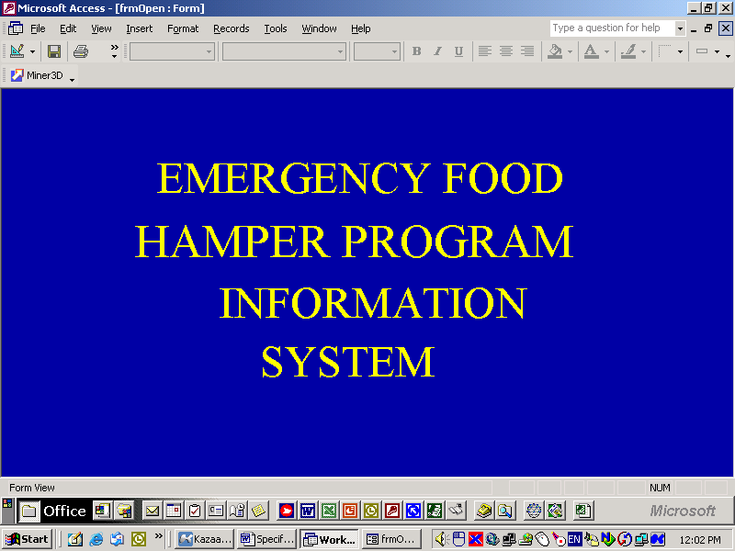

Password Entry

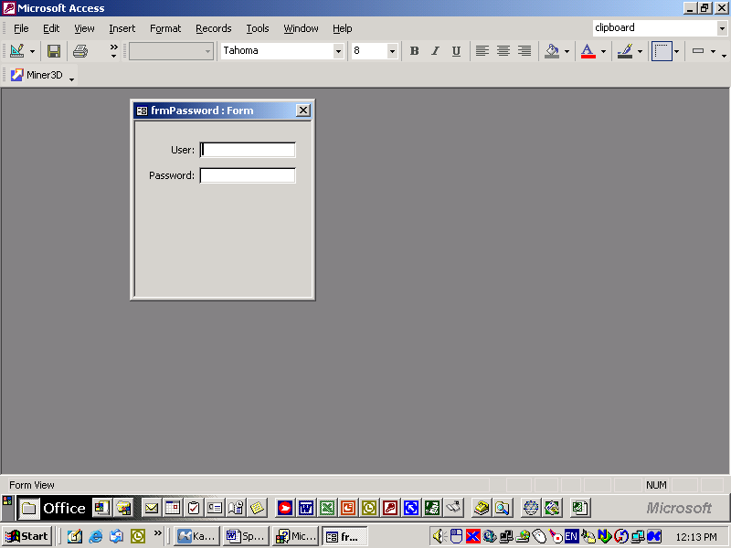

Main Input - Search

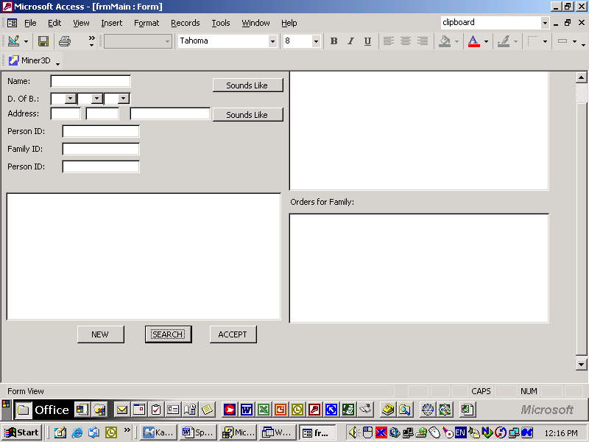

Main - Input - Input - Person

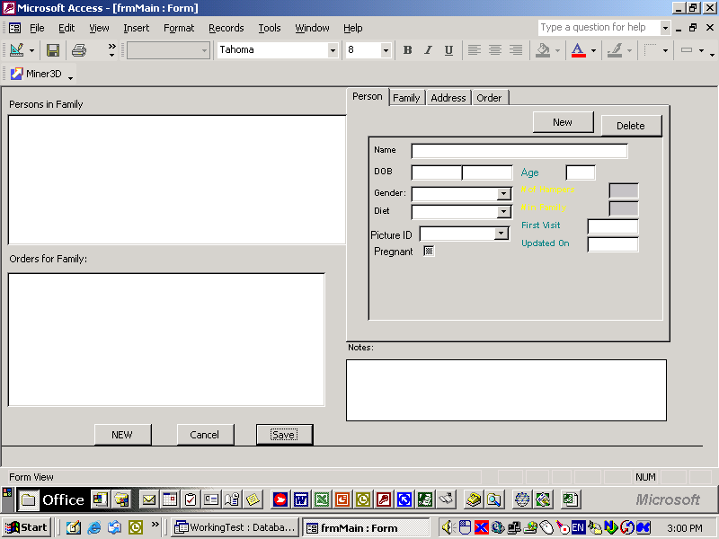

Main - Input - Input - Family

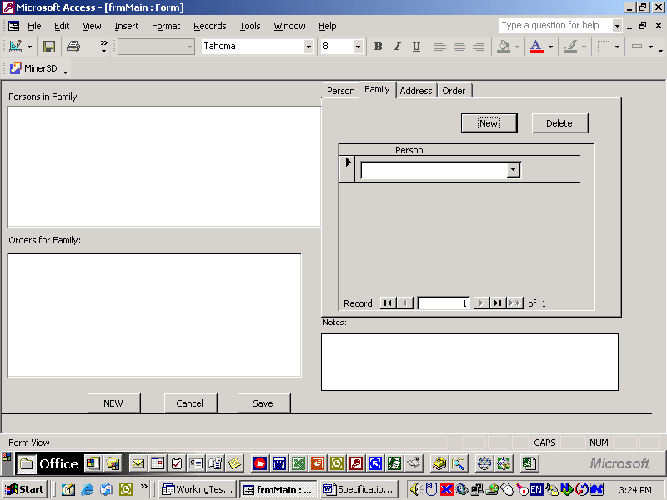

Main - Input - Input - Address

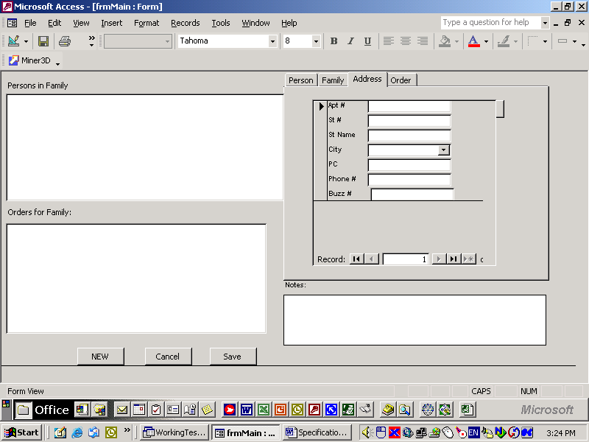

Main - Input - Input - Order

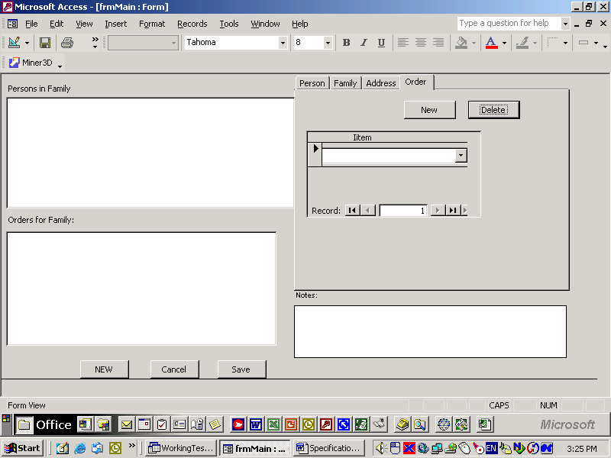

Billing Comparison

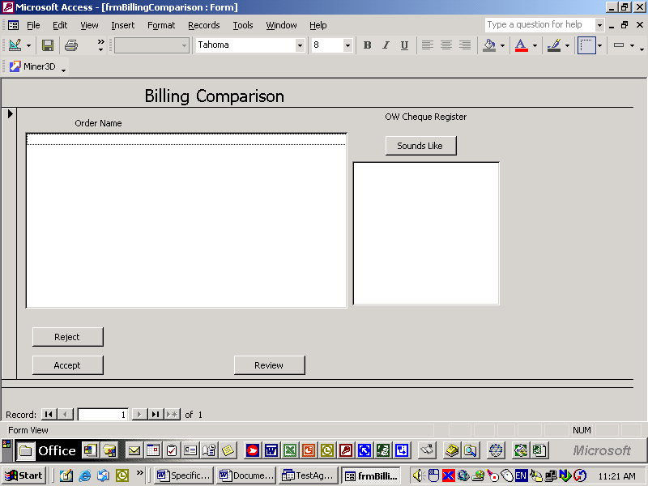

Agency Selection

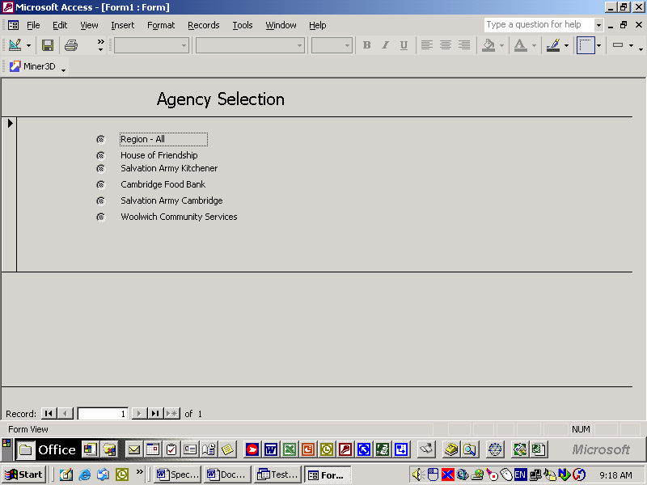

Time Period Selection

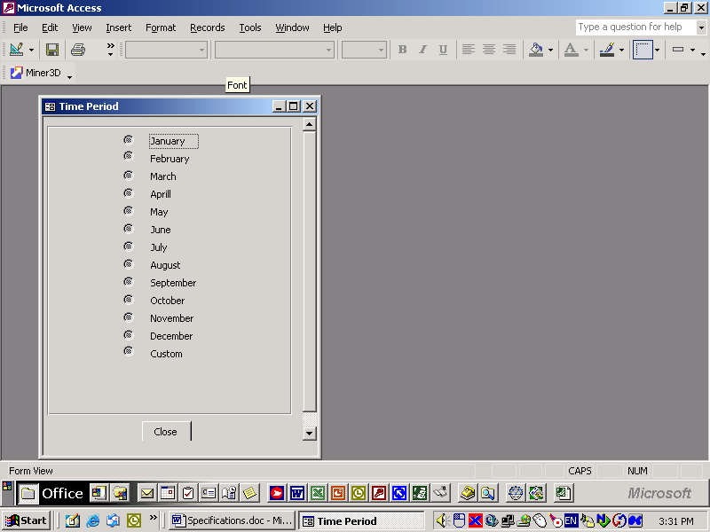

Product Setup

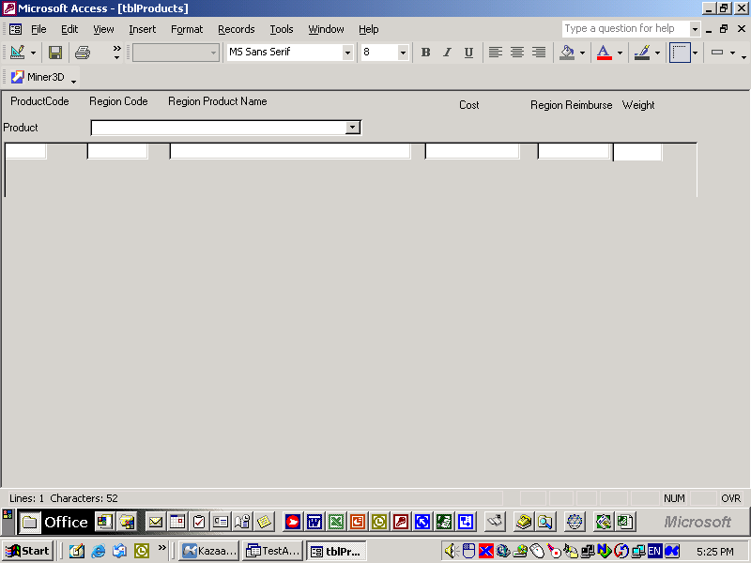

Code Setup - Input

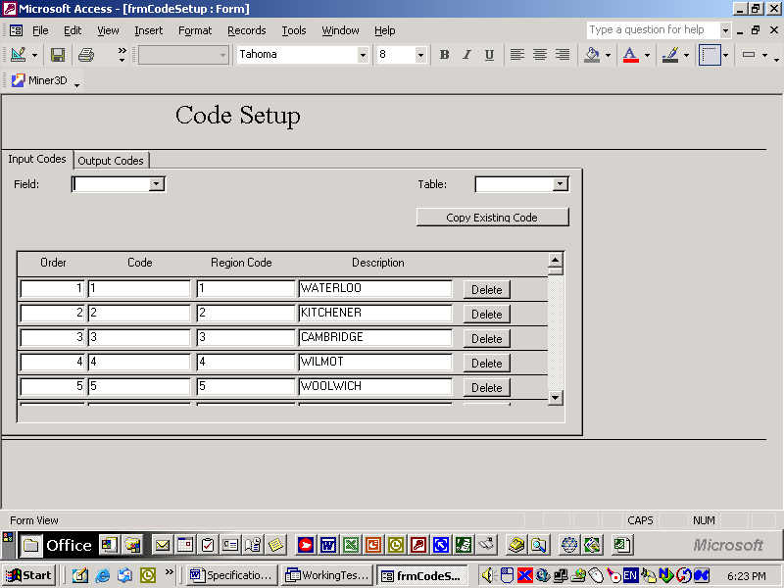

Code Setup - Output

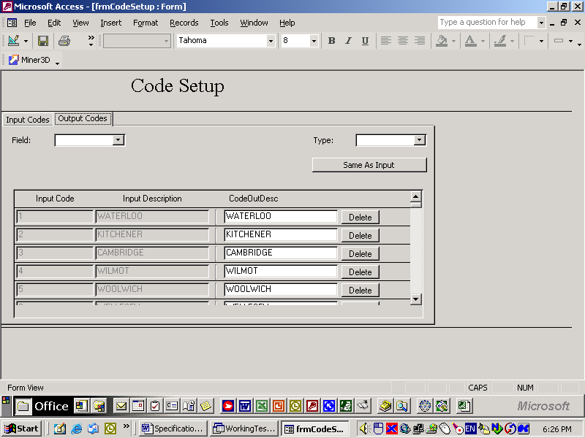

Appendix 3: System Tables

Table Structure

Table | Field | Data Type | Length | File Codes | Comments
tblAgency | AgencyID | Text | 4
 | AgyContact | Text | 30
 | AgyName | Txt | 30
 | AgyStreet | Text | 15
 | AgyCity | Text | 10
 | AgyProv | Text | 2
 | AgyPostCode | Text | 7
 | AgyTelephone | Text | 14 |  | (xxx) xxx-xxxx
 | AgyFax | Text | 14 |  | (xxx) xxx-xxxx
 | AgyEmail | Hyrtext
 | AgySymbol | OLE
 | AgyMaxOrder | Number
 | agyStatsUpdated | Date
 | UpdateBy | Text | 15
 | ModifyDate | Date |  |  | Deft date()
 | CreateDate | Date |  |  | Deft date()
tblPerson | PersonID | Autonumber
 | PerviousID | Number
 | FirstName | Text | 30
 | Initial | Text | 3
 | LastName | Text | 30
 | DOB | Date
 | Gender | Text | 6
 | Diet | Text | 3
 | Pregnant | Yes/No
 | Volunteer | Yes/No
 | VolComments | Memo
 | IDRequired | Text | 2
 | UpdateBy | Text | 15
 | ModifyDate | Date |  |  | Deft date()
 | CreateDate | Date |  |  | Deft date()
tblIncome | IncomeID | Autonumber
 | PersonID | Number
 | Source | Text | 3
 | UpdateBy | Text | 15
 | ModifyDate | Date |  |  | Deft date()
 | CreateDate | Date |  |  | Deft date()
tblFamily | FamilyID | AutoNumber
 | UpdateBy | Text | 15
 | ModifyDate | Date |  |  | Deft date()
 | CreateDate | Date |  |  | Deft date()
tblAddress | AddressID | AutoNumber
 | FamilyID | Number
 | BuzzNumber | Text | 5
 | StreetNumber | Text | 5
 | Street | Text
 | City | Text | 15
 | Prov | Text | 3
 | PostalCode | Text | 7 |  | ANA NAN
 | Telephone | Text | 14 |  | (NNN) NNN NNNN
 | ToDate | Date
 | UpdateBy | Text | 15
 | ModifyDate | Date |  |  | Deft date()
 | CreateDate | Date |  |  | Deft date()
tblNotes | NoteID | AutoNumber
 | FamilyID | Number
 | Note | Memo
 | UpdateBy | Text | 15
 | ModifyDate | Date |  |  | Deft date()
 | CreateDate | Date |  |  | Deft date()
tblFamilyPerson | FamPersID | AutoNumber
 | Family ID | Number
 | PersonID | Number
 | Relationship | Text | 10
 | ToDate | Date
 | UpdateBy | Text | 15
 | ModifyDate | Date |  |  | Deft date()
 | CreateDate | Date |  |  | Deft date()
tblOrder | OrderID | AutoNumber
 | OrderDate | Date
 | AuthorizationNo | Text | 10
 | Delivery | Yes/No
 | BilledNo | Number
 | NonBilledNo | Number
 | UpdateBy | Text | 15
 | ModifyDate | Date |  |  | Deft date()
 | CreateDate | Date |  |  | Deft date()
tblOrderDetail | Quantity | Number
 | Item | Text | 10
 | UpdateBy | Text | 15
 | ModifyDate | Date |  |  | Deft date()
 | CreateDate | Date |  |  | Deft date()
tblProducts | ProductID | Autonumber
 | ProductName | Text | 30
 | ProductCode | Text | 5
 | RegionProductCode | Text | 5
 | RegionProductName | Text | 30
 | Cost | Currency
 | RegionReimburse | Currency
 | Weight | Number
 | UpdateBy | Text | 15
 | ModifyDate | Date |  |  | Deft date()
 | CreateDate | Date |  |  | Deft date()

Appendix 4: Calculated Variables

Calculated Variables

Name | Function | Procedure
Name | nameInput(newNameInput)_ | mNewInputName() = Split(newNameInput, "(", -1, vbTextCompare) If UBound(mNewInputName) > 0 Then mFirstName = Left$(mNewInputName(0), Len(mNewInputName(0)) - 1) mLastName = Left$(mNewInputName(1), Len(mNewInputName(1)) - 1) Else mLastName = mNewInputName(0) End If
 | nameOutput | TRIM(FirstName) & “ “ & Trim(Initial) & “ “ & LastName
 | NameDisplay | TRIM(FirstName) & “ [“ & Trim(Initial) & “] (“ & TRIM(LastName) & “)”
Age | Age | FORMAT(DATEDIFF(DOB,Now()),2)
Status | Status | IIF( isnull(Todate), “Current” , “Pervious”)
Household Composition |  | Single Parent Families Two Parent Families Childless Couple Single People
Average Single Mother Family Size
Average Single Father Family Size
Average Two Parent Family Size
# of different households receiving n hamper
Number of Different Persons Served
Number of Different Families Served
Number of Different Children Served
Number of New Persons Served
Number of New Families Served
Number of New Children Served
Number of Times Service Provided
Total ACCEPTED Order
Total OW Orders
Total NON OW Orders
Total UNCLEAR Orders

Appendix 5: Master Menu
Master Menu

TOP | SECONDARY | Form/Report | Comment
Input | Master Input | frmMain
 | Billing Comparison
Reports | Preliminary Invoice
 | Preliminary Billing Listing
 | Final Invoice
 | Final Billing Listing
 | Clients Not Eligible Report
 | Cheque Reconciliation Report
 | Hunger Count – Hamper Report
 | Individual Client Profile
 | Family Profile
 | Summary of Clients Served
 | Summary of Services Provided
 | Summary of Services Provided by Month
 | Delivery Report
 | Accuracy, Consistency and Integrity Checklist
Processes | Region of Waterloo Social Service Billings Submission
 | Region of Waterloo Social Service Statistics Submission
 | Region of Waterloo Social Service Statistics Update
 | Year-end
 | System Backup
Maintenance | System Codes Updates
 | System Codes Codebook
 | Password Management Updates
 | Password Report

